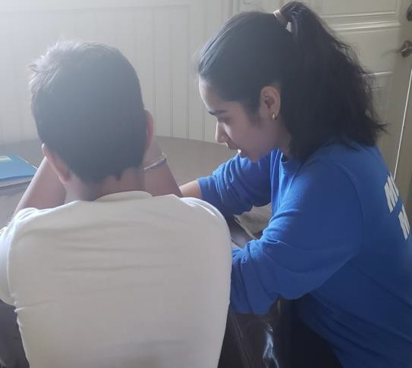 | ANJALI BAL  “Encouraging students by leading and challenging them to succeed”.  SKILLS
 | I have acquired skills in: Leadership, adaptability, flexibility, multi-tasking, mentoring, organization, event-planning, cooperation, maturity, reliability, patience, and perseverance.
PROFILE  I am a grade 11 student at LA Matheson Secondary with an interest in Health Sciences.  My long-term goal is to pursue a career as a pediatrician. I would like to learn how to manage the health of children, including physical, behaviour, and mental health issues.  EDUCATION  LA Matheson Secondary School 2016-Present  - High School Graduation 2021  - Enrolled in Leadership for three years  778-001-0001  anjalibal202@gmail.com | SUMMARY OF SKILLS
Mentoring: Mentored new leadership students and also tutored and mentored students after school.
“As an after school academic mentor, Anjali is patient, kind and task- oriented. She helps other students who are struggling with their work by clearly and patiently explaining complex concepts in ways that make sense to them.” - Mr.Stefan Stipp, Vice Principal at LA Matheson
Leadership: Taking lead in many leadership projects for many years. “Anjali is a very motivated and responsible leadership student. She demonstrates excellent communication and teamwork skills that have allowed her to take the lead in planning, implementing and overseeing a wide variety of school and extracurricular events”- Ms. Cyndy Miller
Reliability: Trusted with serving food to seniors
“Anjali is a dedicated hard worker who takes her volunteering seriously by being punctual, taking directions well, and getting the tasks done in a timely manner”- Linda Christoforou, Director of Volunteers
VOLUNTEER EXPERIENCE

LA Matheson Mustang Mentors (After School tutoring)
September 2019- March 2020
Helped students after school, patiently explained ideas, helped with criteria for tests and quizzes, proofread, taught students with easier methods.
Several School Volunteering Activities
September 2016 - Present
Decorated the school, took photos for yearbook, student council activities, gave tours to parents, and assisted with tours to Japanese students.
Kennedy Seniors Centre Meal Services
December 19, 2019 & January 18, 2020
Served seniors meals and desserts, cleaned the tables and folded tablecloths. Connected and brought hope to lonely seniors.

INTERESTS

- Passionate about writing and listening to music
- Enjoy taking professional pictures
- Value health and fitness
REFERENCES

Mrs. Sekhon - Math Teacher
LA Matheson Secondary Phone: 604-001-0001
kaur_sekhon_h@surrey.ca

AWARDS

Creative Writing and Composition 2019 First Class Honour Roll Student 2017 Top 25% Gauss 2017
1st place in Gauss 2016 Proficiency Award 2016
Ms. Miller - Retired Leadership Teacher
LA Matheson Secondary Phone: 604-002-0002
miller_cyndy@surrey.ca

Linda Christoforou - Director of Volunteers
Kennedy Seniors Recreation Phone-604-003-0003 christoforoulinda@email.com

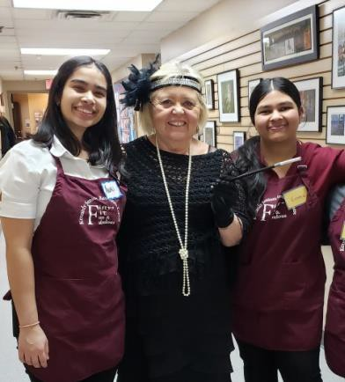
778-001-0001
anjalibal202@gmail.com

